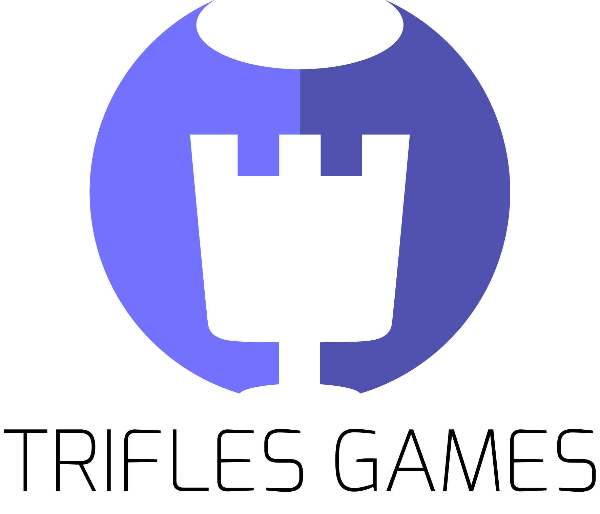

City Pack

Trifles Games has provided for you 👾

This is a low polygon city package that you can use for your games. You can find houses, buildings, vehicles, and several objects which are created with different color options. You can build up your own low-poly city by arranging these as you wish.

(The detailed demo scene is included).

**Buildings (x38)**

House x12, Apartment x9, Garage x2 Goverment Building, Hospital, Bar, Restaurant x3, Butcher x2, Cinema, Coffee Shop x2, Pizza x4

*Total 114 buildings included 38 different models with 3 different color options.*

**Vehicles (x15)**

Ambulance, ATV, Bus, Car x2, Sport Car, Jeep x3, Limousine, Mini Truck, Police Car, Truck x3

*Total 45 Vehicles included 15 different models with 3 different color options.*

**City Props (x20)**

Bench x2, Bus Station, Chair x2, Table x3, Garbage Container, Flower, Street Lamp, Traffic Lamp x2, Tree x5, Umbrella x2

**Roads (x14)**

These are modularly prepared 14 road parts

You can check the screenshots for detailed review.

**Follow us!** Trifles Games ♥

First of all, you need to install post processing asset from the package manager.

You can install it from Windows->Package Manager and search for post processing.

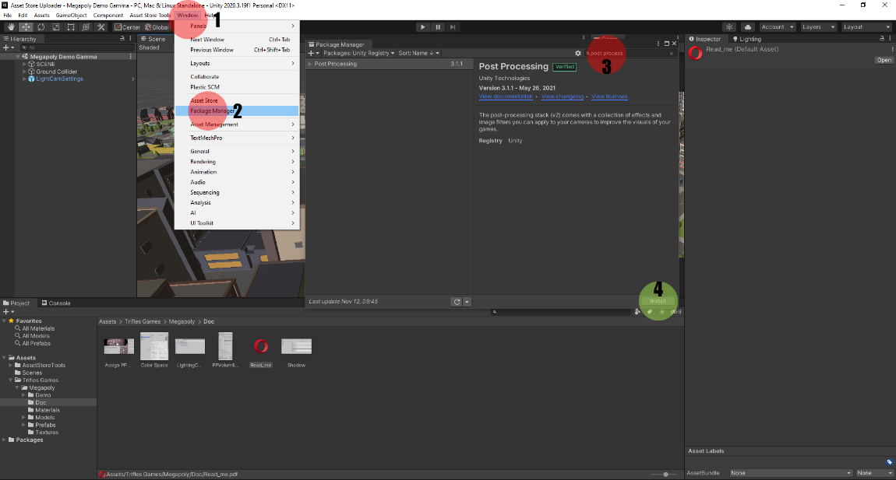

Then remove "Post Process Volume" and "Post Process Layer" from the "Main Camera"

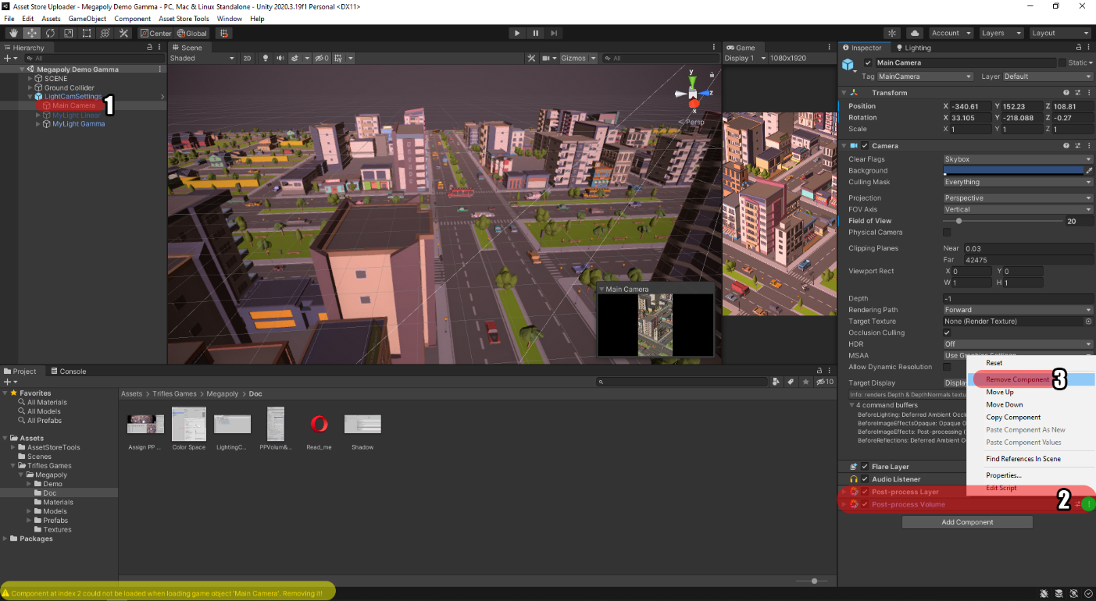

and then add them again to Main camera (Unity can cause bug, that is why we delete and add again) assign MegapolyPP profile to profile in the Main camera. Screen shots are in Doc folder.

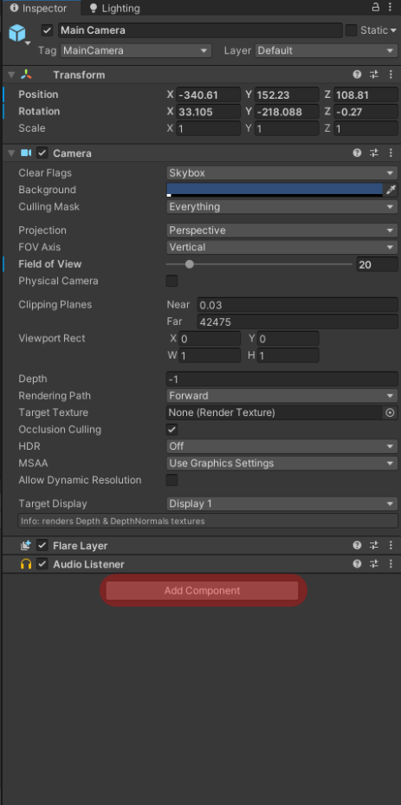 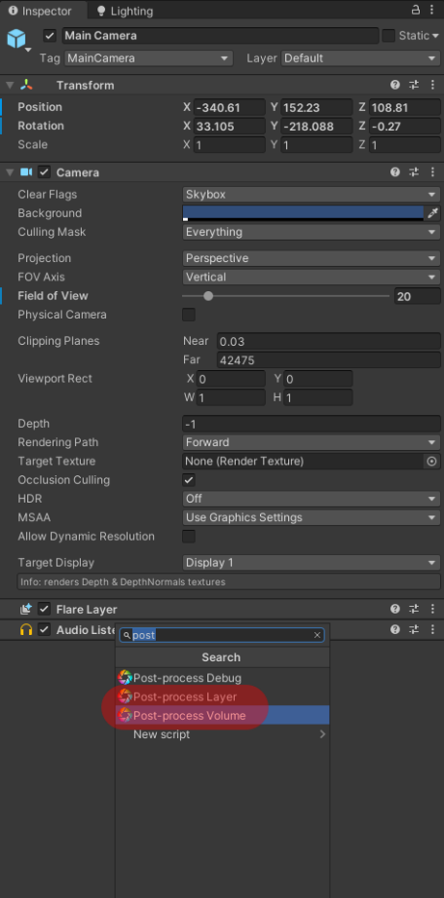 metin içeren bir resim

Açıklama otomatik olarak oluşturuldu

To get same result, you have to change your project settings. We put settings for shadow and pixel light count as screen shot. You can open for it from

Edit > Project Setting > Quality

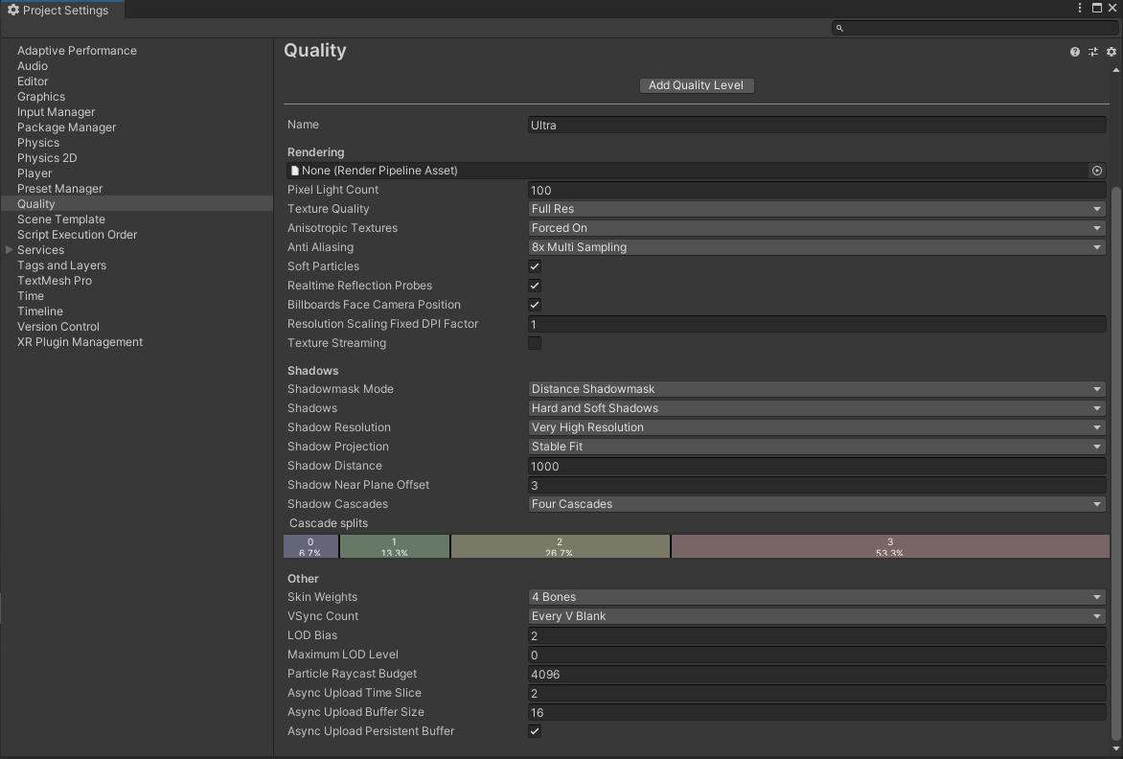

Thank you for purchase



[Trifles Games](https://triflesgames.com/)

[support@triflesgames.com](mailto:support@triflesgames.com)